Dear MIL-1553-TD Engineer and User
The MIL-1553 Trigger and Decode Option are available on LeCroy Oscilloscopes. This Feedback and Satisfaction Survey is aimed at those actively using it, and from whom we would like to gather first hand impressions. The goal of this questionnaire is to gather solid information, guiding us for further developments of the firmware. We thank you in advance for your time. The document is structured by dialogs, table and annotations. Feel free to skip entire sections when you are not using them at all.

1 Decode Dialog
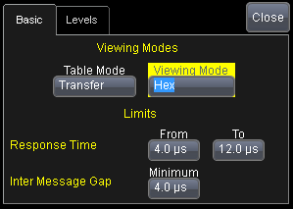

1 | In the above Dialog, there are 2 choices for the “Table Mode”: “Word” and “Transfer”. Can you approximately rate your usage of both modes?  Could you explain in which case you prefer to use one or the other Mode?  a) I prefer the “Word Mode” for the following type of work:  b) I prefer the “Transfer Mode ”. for the following type of work:
  Word Mode | Transfer Mode
  % | %
2 | In the above Dialog, there are 2 choices for the “Viewing Mode”: “Binary” and “Hexadecimal”. Can you roughly rate your usage of both modes (for example 50/50 or 0/100 or 30/70)?
  Binary viewing | Hexadecimal Viewing
  % | %
3 | Are there other rendering modes then the above ones that would be useful to your work? If yes, could you describe them briefly?
4 | In the above dialog, the “Limits” values are used as boundaries outside which the decoded values in the Table are expressed in red, indicating an error. Is this feature known to you? Is it useful to you?

2 Level Dialog
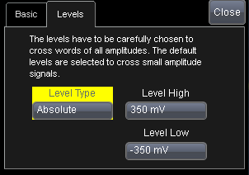

5 | In the above dialog, there are 2 choices for the “Level Type”: “Absolute” and “Percent”. Can you approximately rate your usage of both modes?
  Level Type Absolute | Level Type Percent
  % | %
6 | Could you explain in which case you prefer to use or the other Level Type?  a)I prefer the “Absolute level” for the following type of work or in the following situation:  b)I prefer the “Percent Level” for the following type of work or in the following situation:
7 | Are there other level controls you would find useful?

3 Search Dialog
Searchable columns for MIL 1553
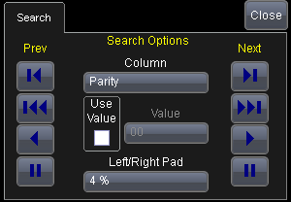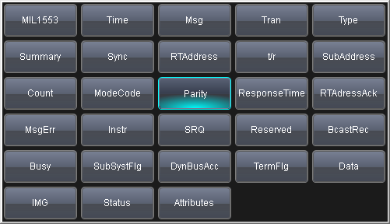

8 | In the above dialog, there are several choices of columns to be used for the search. Which columns do you use most frequently to search a stream of messages?
9 | Do you find the  buttons useful?
10 | Do you find the  buttons useful?
11 | Do you find the buttons useful?
12 | Are there other search features that you would welcome?

4 Table Export, Column Picker
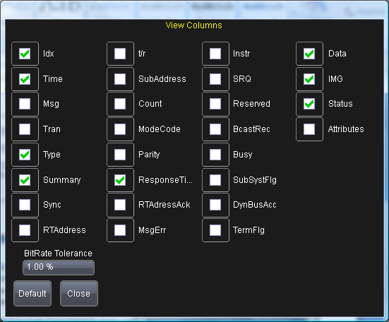

13 | The above popup dialog lets you choose the columns shown by the Decode Table, in order to minimize the clutter on screen.  Which columns do you usually remove?  Which columns do you usually keep visible?
14 | Are the column names and abbreviations easy to understand for you? Are there names that you would suggest to change for better understanding?
15 | In your work, do you use the Table Exporter (into CSV files)?
16 | Since the column visible are also those exported, the same picker is used to drive the export.  When exporting the table, do you usually use the same column set as viewed on the screen?
17 | If you use the Export Table feature, what do you do with data?
18 | Are there other features of the Table Viewer and Exporter that would help you do your work?

5 Decoding Algorithm
19 | Does the Decoder always behave as expected?
20 | Did you encounter any difficulties to get the first decodes traces on screen?
21 | How long did it take you to get the first decoded trace on screen when you started using the tool?
22 | When decoding, are the default thresholds (+- 350 mV) appropriate, or did they have to change them? If yes to which levels?
23 | Do you sometimes decode several protocols at the same time?
24 | Do you have unconnected Remote Terminals (RTs) on the bus?
25 | Do you use the RT to RT Transfer mode, if yes is all the content correctly decoded?
26 | Are there additional Decoding features that you would recommend to implement?

6 Trigger Dialogs, Transfer Mode
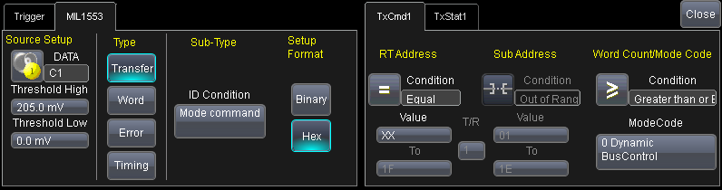
27 | Have you used this trigger mode?
28 | Do you find the dynamic tabs on the right easy to use?
29 | If you use this mode, are there unimplemented features that would help you?
30 | If you use this mode, can you check the Transfer types you use?
  BC-RT | RT-BC | RT-RT | MC | MC+Data Xmit | MC+Data Rcv | BC-RT Broadcast | RT-RT Broadcast | MC Broadcast | MC+Data Broadcast

7 Trigger Dialogs, Word Mode
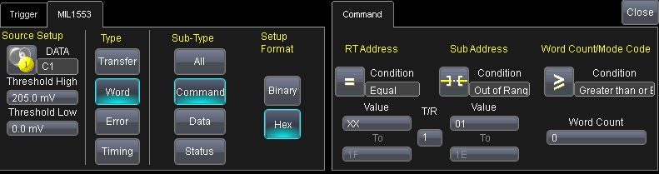
31 | Have you used this trigger mode?
32 | Is the Command Word definition Dialog on the right clear to you?
33 | Were you able to catch the events that you were looking for?
34 | If you use this mode, which ones of the 3 Word types do you use?
  Command | Data | Status
35 | Is there a functionality that you are missing and would appreciate to see implemented?

8 Trigger Dialogs, Error Mode
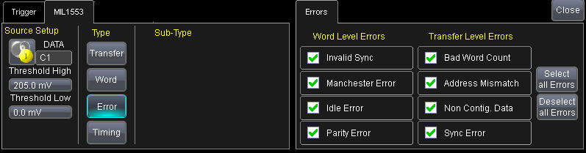
36 | Have you used this trigger mode ?
37 | Are the different error selections on the right clear to you?
38 | Were you able to catch the events that you were looking for?
39 | In the course of doing your work, are there features that you would have liked?

9 Trigger Dialogs, Timing Mode
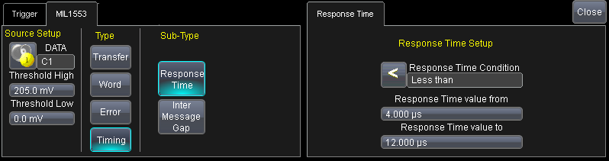
40 | Have you used this trigger mode?
41 | Is this dialog clear to you?
42 | Were you able to catch the events that you were looking for?
43 | Are there feature that would make your efforts more productive?

10 Decoding and Triggering with Amplitude Differences
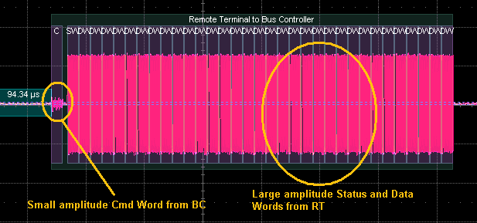
44 | As shown in image above, Mil 1553 signals can exhibit large amplitude differences between the signals generated by the RT and the BC.
45 | Are you often faced with this situation?
46 | When observing such signals, have you always been able to decode and trigger?
47 | What method(s) did you apply to decode in spite of the amplitude difference? (i.e. adjust levels, shorten record, apply filters on the channel, use Word Decode instead of Transfer Decode)?
48 | Do you think that this particular aspect should be improved?

11 Relative Usage of Table and Annotation
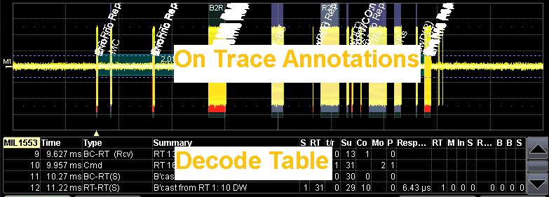
49 | As shown above, the Decode Table and the On Trace Annotations convey the results of the decoding to the user. First indications indicate that users have many different ways of using both renderings.  How would you rate your usage of both features
  Use of Table | Use of Annotations
  % | %
50 | Can you tell us how you usually combine both tools (Table and Annotation) usage?
51 | Do you think that the number of lines of the table (1 to 20) is sufficient ?
52 | Do you use the ability to click on a line of the Table to open the zoom on that Transfer?
53 | Do you use the ability to select a portion of the decode trace to position the decoded zoom?
54 | Are there features related to the Zoom and Table that could help your work that you would like to suggest?

12 User Profile Questions.
In order to better serve the MIL-STD-1553 community, LeCroy and Lahniss would like to gather some user information profile.
55) Approximately how many hours have you been using the LeCroy/Lahniss MIL-STD-1553 Trigger & Decode System (TD)?
< 5  hours | 5-20  hours | 20-50  hours | > 50  hours

56) Approximately how many years have you been involved with the MIL-STD-1553 Serial Bus?
< 1  years | 1-5  years | 5-10  years | > 10  years

57) How well do you know the MIL-STD-1553B (21 September 1978) specification?
Not at all | Some | Well | Expert

58) How well do you know the DDC “MIL-STD-1553 DESIGNER’S GUIDE” ?
Not at all | Some | Well | Expert

59) In which Life Cycle phase have you used MIL-STD-1553 over the years?
Life cycle  phase | System  level | Sensor  level | Actuator  level | Integrated Circuit  level
Design
Implementation
Debug
Maintenance

60) In which application have you used MIL-STD-1553 over the years?

 | Military | Civilian
Space born
Airborne
Ground systems
Underground
Underwater

61) Have you used the 1773 protocol?

62) Have you used 1553 at speed other then 1 Mb/s? if yes at which speed?

63) Can we contact you if we have further questions?

Thanks in advance for your help.

